**Chapter – 1**

**Recognition of Need**

**1.1 Introduction**

* **Preface:**

Rajshahi Technical Training Center is one of the old and large technical training centers in the history of skills development in Bangladesh. This technical training center is established to train the manpower for local and global market. Training is delivered in different employable trade as per the demand of local   and overseas job market. In keeping with changing Technology Rajshahi Technical Training Center is capable to start any courses on emerging technology. Course curriculum of RTTC is always updated in line with demand. Innovation in all sectors is always considered in teaching-learning. Technical Training Centre, Rajshahi always thinks for skills and quality of graduates. Since knowledge and skills are becoming the future currency, so Rajshahi TTC always try to do the best and the new things.

* **Brief History:**

Technical Training center, Rajshahi of north Bengal is one of the famous TTC among the old 11 TTCs. It works in the direction of Bureau or Manpower, Employment & Training under the Ministry of Expatriates welfare & overseas Employment of Government of the people’s Republic of Bangladesh.

Rajshahi Technical Training Center was established in 1967 to provide unemployment people by skill training program. This institution initially stared with the financially & technical assistance of SEATO. Now S.S.C (voc) & Short courses are successfully going on. The objective of short Courses is to produce skill human resources for employment for earning foreign currency.

Very recent, Computer Graphics Design lab and Auto CAD Lab was remodeled under the financially & technical assistance of KOICA (Korea International Cooperation Agency).

The center is now going to offering CBT&A programs under new National Skill Development policy with a view to impart knowledge and skills, to the trainees using modern technology in keeping with the changes in the local and global market.

**1.2 Objectives of Technical Training Center, Rajshahi**

* To ensure that all trainees have the technical skills that they needed.
* To maintain the services & products.
* To motivate trainees to achieve world class skills.
* To decrease the risk of training place that the trainees can feel safe.
* To upgrade professional and managerial skills.
* To provide courses in digital format like online system of teaching.
* To encourage the trainees to achieve their goal
* To provide opportunity of skill development and technical education to all sections of the society without any gender bias.
* To ensure the quality of environment.
* To provide positive attitude towards science and technical part.

**1.3 Vision and Mission of the organization**

* Facilitating world-class Department of Technical Education, Training and Skill Development through emphasis on developing high quality institutions, academic excellence and innovative research and development programmers.
* To provide leadership in assuring quality and in stimulating innovation in technical sector.
* Anticipate and prepare for the changing environment and the future needs in pursuits of technical advancements.
* The ability to adapt and upgrade individual skills in a rapidly changing world
* To assist the people in making educational and career decisions.
* To make informed consumer decisions and apply practical life skills.​
* To impart Technical Education & Training, to provide substantial number of technicians in different disciplines for the emerging industrial fields of the country.
* Promoting industry-institute interaction for developing new products, services, and patents.
* To Transfer technical knowledge at the grassroot level.

**1.4 Problem Identifications:**

**1.4.1. No online admission system**: Students cannot enroll or admit themselves using website. There is option for offline admission but this is not efficient and cost effective. Offline admission system is very complex system and it it very hard to maintain proper time /schedule in this system. There is need of enough manpower in this system which is not cost effective. If they make the admission system in online students from distant area can easily admit themselves.

**1.4.2. Absence of student’s** **profile:** They don’t provide individual profile for students, employee and teachers. If they could give or maintained individual profile, student’s could view their result, can get update about their course, routine and notice. This is a very systematic way to maintain student’s profile. Student’s can see their result and grade individually. This system will make institution’s privacy more strong. And also teacher can monitor improvement of the student.

‘Sign-up’ option should be added on the website, so that when anyone do sign-up by giving necessary information a profile will generate.

**1.4.3.** **Lack of online resource:** There is not any syllabus, details and course curriculum for specific course in the website. If students can see the course curriculum on the website they will get some advanced idea. And, there is lack of list of necessary books, pdf, article and video tutorial about a particular course. Student’s will not get proper idea about their courses before admitting themselves. There are no necessary pdf files or books. So, during study they will not get enough materials and resources.

**1.4.4. Online/mobile banking:** At least course fee and admission fee should be received using mobile banking such as bkash, rocket etc. Now a days, mobile banking is available and vastly used. If the authority receive payment by mobile banking ,student’s will get benefit. This system will help the authority to handle the situation in a more systematic way and efficiently. It will consume less time and less number of employee. The environment of the institution will be more stable, training and teaching will not be hampered.

**1.4.5. Shortage of training of trainer’s:** In this organization there is a critical shortage of training of trainers which can become threatening for the future training program. The trainers teach the trainee according to their previous learning. The trainers of various sectors are well experienced -no doubt but to keep pace with this competitive world by their skills, they should be trained. Without proper training they can’t teach the trainee properly what the trainee actually needs to know to prepare themselves for suitable jobs.

**1.4.6. Not having updating curricula:** Technical Training Center (TTC), Rajshahi has 16 different fields of training. All the fields have particular curricula in order to enhance student learning and facilitate instruction. But these curricula are not totally up to date. Curriculum is the central guide for teaching and learning. But by this not updated curriculum the trainees are taught subjects or concepts that are no longer relevant. Thus, the training may not be so much effective for the trainee.

**1.4.7. Insufficient performance monitoring and evaluation:** The trainee of TTC can take short term courses which duration can be 6 months or can participate in long term courses which duration is more than 1 years. There is a vocational board which conducts the evaluation of the trainee. But in this organization, internally there has no option to evaluate the performance of the trainee. By this internal evaluation the trainee can know their lacking and correct them before the final evaluation of the vocational board. Even the organization does not arrange “class test” type examination to monitor whether the trainee actually can perform the tasks.

**1.4.8. Bad condition of training car:** The cars, that have used in driving trade, are have in very bad condition. The are certainly not in shape of driving & it is quite risky to a car in that condition. They also use the TTC inner road as driving way. But both the authority & the instructor are willing to use them in for training purpose. Again, they have better quality cars. But they don’t use it for driving purpose. Which is nothing but negligence of the authority.

**1.4.9. Shortage of recreation:** There in a small field in TTC area. But, that one not able to cover up the annual program for a single trade. Again, the annual program is only for those students those are enrolled in the long-term courses. But there are no such things for the students on short-term courses. Further, they don’t have any scope of sightseeing tour. Anyway, recreation do impact on education. Shortage of recreation can be a great problem in long run.

**1.4.10. Shortage of security guard:** The TTC area is quite big with 16 trade & intermediate level college education system. Again, they have a separate area for women training purpose. But, in this whole area, there is not a single guard checkpoint. Even in the main gate of TTC there is a guard. But he also not concern about the outsider who came into this area. Anyone can roam into the area, without ant permission. It may normal for an educational institute, but for women’s separate area of training, it is uncomfortable to them. Again, some guard’s checkpoint can observe the area in better way.

**1.4.11 Insufficient advertisement:** Only the proper advertisement can give the appropriate information about the organization and can depicts the significance of technical knowledge in this modern era. This organization manages student/trainee by submitting leaflet, giving post on various social media and through the newspaper. Thus a few people can know about the importance of technical knowledge and skills. For this lack of organizational advertisement, it creates the shortage of the number of the trainee. There was so many modern equipment of high cost which were imported from Korea but most of them are being unused for the lack of trainee.

**1.4.12 Not having cafeteria:** In this organization, there is no canteen or cafeteria. During the break time of the courses, there is on chance of the trainee to get foods inside the campus. Even there is no tea stalls or hotel nearby the organization. So the trainee have to go a long distance when they need to take any food. After taking the snacks from the long distance, when they come back to their classes, they often miss some portion of the course lecture. This reason is disrupting their training.

**1.4.13 Lack of Man Power:** In this time there are 1500 students/trainee who have enrolled in various courses. For their training, there are only 55 instructors. The number of instructor is very smaller compare to the number of trainee. We have also learned that there is only one foreign instructor from Korea who acts as a monitor of the training courses through online. It is very difficult task for a monitor to supervise all the arena of the training courses.

**1.4.14 Inadequate Staff Quarter:** There are only 5 two storied building in the compound for the instructors where there works 55 instructors in current time. The facilities of this organizations can support only 10 families of the instructor. Most of the instructors remain deprive of the accommodation facilities. So they have to rent houses outside of the organization at a high cost. Moreover, many instructors have to come from a far distance. In this case, it adds transportation cost with the living cost which greatly hampers the financial condition of the instructors.

**1.5 Conclusion:** Technical Training Center (TTC), Rajshahi has its great mission and vision and this organization is trying to fulfil its organizational goal. While doing initial survey on the existing system of TTC, we found some problems. But we don’t know whether these problems can be solved or not. This can be understood after initial feasibility. Thus we will try to find out the solution of these problems and go through some sequential stages to build up a candidate system.

Chapter-2

Initial feasibility studies

**2.1 Introduction**

An initial investigation culminates in a proposal that determines whether an alternative system is feasible. A proposal summarizing the thinking of the analysis is presented to the user for review. When approved, the proposal initiates a feasibility study that describes and evaluates candidate system performance requirements.

Depending of the results of the initial investigation, the survey is expanded to a more detailed feasibility study. A feasibility study is a test of system proposal according to its workability, impact on the organization, ability to meet user needs, and effective use of resources. It focuses on three major questions:

* What are the user’s demonstrable needs and how does a candidate system meet them?
* What resources are available for given candidate systems? Is the problem worth solving?
* What are likely impact of the candidate system on the organization? How well does it fit within the organization’s master MIS plan?

Each of the question must answer carefully. They revolve around investigation and evaluation of the problem, identification and description of candidate systems, specification of the performance and the cost of each system and final selection of the best system.

**2.2 Initial feasibility study**

**2.2.1 No online admission system**

It was observed the students cannot enroll or admit themselves using website. Offline admission system is very complex system and it very hard to maintain proper time /schedule in this system. There is need of enough manpower in this system which is not cost effective.

The process can be performed online. If they make the admission system in online students from distant area can easily admit themselves. This process is not worthy cause to make the admission system online, there will be need of buying own server, more technical employee will be needed which are not cost effective.

**2.2.2 Absence of student’s** **profile**

This technical Centre don’t provide individual profile for students, employee and teachers.

This problem is worth solving cause by making individual profile for the students it can be ensured that If student’s can view their result, can get update about their course, routine and notice. Students can see their result and grade individually. And also teacher can monitor improvement of the student. ‘Sign-up’ option should be added on the website, so that when anyone do sign-up by giving necessary information a profile will generate. This process don’t need continuous man power and technical specialist. There will be no need of buying server own self. To create this process resources are also available. And it’s a cost effective way to maintain students’ progress.

**2.2.3**  **Lack of online resource**

There is not any syllabus, details and course curriculum for specific course in the website. If students can see the course curriculum on the website they will get some advanced idea. And, there is lack of list of necessary books, pdf, article and video tutorial about a particular course. Students will not get proper idea about their courses before admitting themselves. There are no necessary pdf files or books. So, during study they will not get enough materials and resources.

To publish these information, the technical center need having own server and technical people which is not economically effective. That’s why this process is not worth solving.

**2.2.4**  **Online/mobile banking**

The course fee and admission fee should be received using mobile banking such as bkash, rocket etc. Now a days, mobile banking is available and vastly used. If the authority receive payment by mobile banking, students will get benefit. This system will help the authority to handle the situation in a more systematic way and efficiently. It will consume less time and less number of employee. The environment of the institution will be more stable, training and teaching will not be hampered.

This problem is not worth solving cause the technical center need to buy own server and need more technical people. Moreover for maintain online banking the technical center will be dependent on third party online banking system like bkash, rocket etc. which is not suitable for privacy of the technical center.

**2.2.5**  **Shortage of training of trainer’s**

This organization have a critical shortage of training of trainers which can become threatening for the future training program. The trainers of various sectors are well experienced -no doubt but to keep pace with this competitive world by their skills, they should be trained. Without proper training they can’t teach the trainee properly what the trainee actually needs to know to prepare themselves for suitable jobs.

This problem is worth solving because nowadays there have thousands of resource for learning and getting required informationfrom online. From these resources trainers can trained themselves with the updated system of specific field.

**2.2.6 Not having updating curricula**

Technical Training Center (TTC), Rajshahi has 16 different fields of training. All the fields have particular curricula in order to enhance student learning and facilitate instruction. But these curricula are not totally up to date.

This problem is not worth solving because the ongoing curricula is good enough to learn and gain knowledge and skill about the individual field of training. That’s why there have no need of new or updated curricula.

**2.2.7 Insufficient performance monitoring and evaluation**

The trainee of TTC can take short term courses which duration can be 6 months or can participate in long term courses which duration is more than 1 years. In this organization, internally there has no option to evaluate the performance of the trainee. Even the organization does not arrange “class test” type examination to monitor whether the trainee actually can perform the tasks.

This problem is worth solving because it is very easy and cost effective to monitoring performance and evaluation by taking day by day class test or weekly test. This will help the students to know about his own situation and where he/she need to progress.

**2.2.8 Bad condition of training car**

The cars, those have used in driving trade, are have in very bad condition. They are certainly not in shape of driving & it is quite risky to a car in that condition.

This problem is not worth solving because they use the TTC inner road as driving way. That’s why there have no risk of vast accident. Again, they have better quality cars so they can change the training car whenever they want.

**2.2.9 Shortage of recreation**

In the TTC there have no event or any programe for recreation of the students. Again, the annual program is only for those students those are enrolled in the long-term courses. But there are no such things for the students on short-term courses. Further, they don’t have any scope of sightseeing tour.

This problem is not worth solving because there have a small field in TTC area which is not able to cover up the annual program for a single trade. The students who enrolled in short-term courses have not enough time for recreation because it’s time duration is only 6 month. In this short period of time there have not much impact of recreation in training process rather than it can be a west of time.

**2.2.10 Shortage of security guard**

The TTC area is quite big with 16 trade & intermediate level college education system. Again, they have a separate area for women training purpose. But, in this whole area, there is not a single guard checkpoint. Even in the main gate of TTC there is a guard. But he also not concern about the outsider who came into this area.

This is a large problem of TTC and it is worth solving. Shortage of guard causes lack of privacy and security in TTC area. If there have guard in different area it will prevent any kind crime and give the surety of safety. It will prevent unnecessary gathering of people.

**2.2.11 Insufficient advertisement**

This organization manages student/trainee by submitting leaflet, giving post on various social media and through the newspaper. Thus a few people can know about the importance of technical knowledge and skills. For this lack of organizational advertisement, it creates the shortage of the number of the trainee. There was so many modern equipment of high cost which were imported from Korea but most of them are being unused for the lack of trainee.

This problem is worth solving. Proper advertisement the organization will spread there facility, there vision and mission. Even the people who want to be technically updated will get information about their service and can enrolled themselves in the organization.

**2.2.12 Not having cafeteria**

In this organization, there is no canteen or cafeteria. During the break time of the courses, there is no chance of the trainee to get foods inside the campus. Even there is no tea stalls or hotel nearby the organization. So the trainee have to go a long distance when they need to take any food.

This is a huge problem and worth solving. The organization can establish a cafeteria of their own inside the campus which will help the students to get food easily. As there have no hotel nearby the organization, if there have a café students won’t need to go far away for food. Even from the café the organization can earn some extra money.

**2.2.13 Lack of Man Power**

In this time there are 1500 students/trainee who have enrolled in various courses. For their training, there are only 55 instructors. The number of instructor is very smaller compare to the number of trainee. We have also learned that there is only one foreign instructor from Korea who acts as a monitor of the training courses through online.

This is problem is worth solving. Lack of trainer will cause insufficient knowledge of the student in their individual training field. The organization need to appoint more instructor in different field so that the learning process become more effective. It will encourage people to enroll themselves in different field of training.

**2.2.14 Inadequate Staff Quarter**

There are only 5 two storied building in the compound for the instructors where there works 55 instructors in current time. The facilities of this organizations can support only 10 families of the instructor. Most of the instructors remain deprive of the accommodation facilities. So they have to rent houses outside of the organization at a high cost. Moreover, many instructors have to come from a far distance.

This problem is worth. By increasing staff quarter the organization can provide more facility for the instructor. More staff quarter will encourage the people to appoint themselves as an instructor. It’s safe and convenient for instructor to do their job effectively. It will reduce instructor economical losses. In future when the organization turn on more training field, more staff will be needed. That’s why sufficient staff quarter is much needed.

**2.3 Conclusion**

In this chapter we have done the initial feasibility study by which we can understand whether we can proceed with the problems or not. This is a crucial decision point in the life cycle. Many project die here, whereas the more promising ones continue through implementation. Changes in the proposal are made in writing, depending on the complexity, size, and cost of the project. It is simply common sense to verify changes before committing the project to design. We have to analyze more deeply to understand the situation and then finally we can assure that the identified problems can be solved.

Chapter-3

Information Gathering

**3.1 Introduction**

Information gathering is an art and a science.It requires technique ,sensitivity and knowledge in what and how to gather information. Additionally, the methodology and tools for information gathering require training and experience that the analyst is expected to have.So ,we can say it is a very sensitive part in system analysis because feasibility study and later parts depend on it.

To gather information from the organization different kinds of tools are used. The analyst must decide on the information gathering tool and how it must be used. Although there are no standard rules for specifying their use, an important rule is that information must be acquired accurately,methodically, under the right conditions and with minimum interruption to user personnel. So, it is necessary to be familiar with various information gathering tools. Each tool has a special function, depending on the information needed.

As we are going to make an analysis on the prevailing system of Technical training center,rajshahi. So we have gathered the required information from different sections of technical training center using four tools.

**3.2 Information gathering using different tools**

In this section we have presented the information we have collected from the respective

organization.

**3.2.1 Forms, documents and statistical chart of technical training center,Rajshahi.**

**3.2.1.1 Name of all the department**

Here is the list of all the department and course.This institution have almost all the necessary and useful courses .

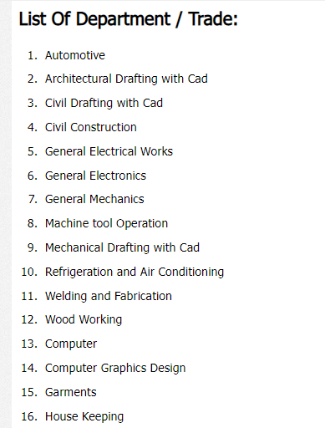

**3.2.1.2.Advertisement for admission:**This is a notice which is published before the admission season.Here we can see a name of a course,minimum educational qualification as a requirement, time range of the course.And we can also know the fee requirement for this particular course.

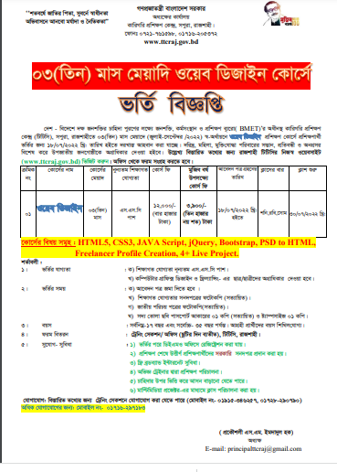

**3.2.1.3 Training schedule**

In this schedule there is list of the subcourses which are part of a course.Admission date for a specific course.The “course run” means the months on which training of these course will be given.This duration is generally 3-5 months or even years depending on the course.We can also be able to know the seat capacity for a specific course.

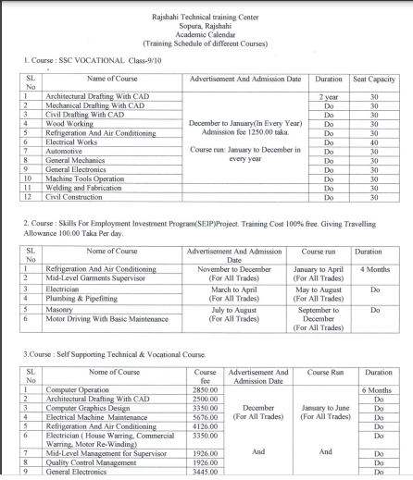

**3.2.1.4 citizen charter**

This is the list of the requirement,the information about how they will get the circular,the process of selection/admission,approximate time of admission for a specific course.They give circular by by giving advertisement in newspaper,supplying liflet,by giving notice to website.Applicant can get required form from the training section/office and website.After receiving application they take competitive admission test and select student.There is a specific time and a specific employee is assigned for all the courses.

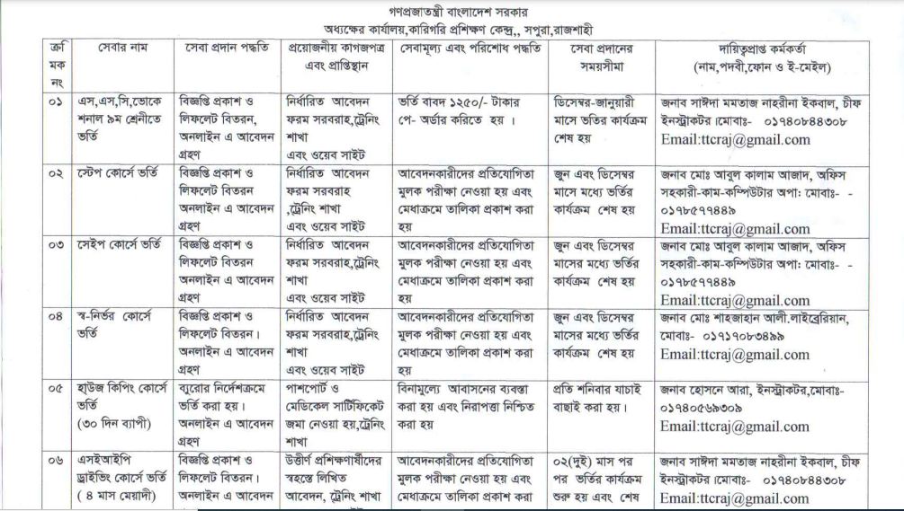

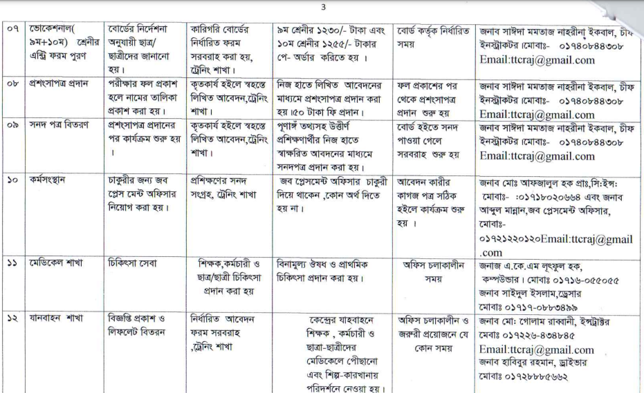

**3.2.2 Observation on working process of technical training center** :

Actually, this is known as onsite observation. Onsite observation is a very effective tool to gather information. The major objective of on-site observation is to get as close as possible to the real system. Keeping in mind the following questions, helps to gather important information observing the system.

• What kind of system we are observing.

• The people running the system and who are important people of the system.

• The history of the system and the evolution of the system to current stage.

• How the system responses to internal and external crisis. Four alternative observation methods are used usually.

• Observation can be natural or contrived. A natural observation occurs in employee’s place and contrived observation is set up by the observer in a place like laboratory.

• It can be obtrusive or unobtrusive. In an obtrusive observation the respondent knows he/she is being observed but in an unobtrusive observation the respondent doesn’t know.

• It can be direct or indirect. A direct observation takes place when the observer actually observes the subject. But in case of indirect observation mechanical devices are used to capture information.

• It can be structured or unstructured. In structured observation the observer looks for and records specific action. But in case of unstructured method, the observer is in a situation to observe whatever might be pertinent at the time.

We have observed the working process of technical training center,Rajshahi several times. Our observations were natural, direct, obtrusive and unstructured. Our observations are given below-

1.During our observation we saw that trainers are busy in the classroom.Specific skilled instructor is assigned in every section.Instructors are skilled and enough trained.Every instructor have to go through a training phase.In the general electrical works section trainees learn about the basic of electrical,they learn uses of various electrical tools in the lab and worked with those tools practically in the lab.In the final examination the give practical and written test.They also give viva .Officer comes from board in the exam time.

2.Technical resources are available in the training center.But there is not enough instructor for proper training.Instructors don’t know the use of multimedia projector.They give theoretical knowledge by writing on the white board.So it becomes quite hard for the students to understand and realize about a topic.They can see practical video and can get updated knowledge by the use of multimedia projector.

3.Number of students in the cources is not balanced.Some cources have students of full capacity but some cources have a few number of students.Main reason of this problem is lack of advertisement.They give circular using newspaper.But in this time most of the people don’t raed newspaper rather most of them are on social media.So if they give advertisement on social media it will be more efficient and effective.

4. During our observation the employees were very helpful and they were giving us information willingly when we told about the reason of observation.Instructors were busy in the classroom.Principle sir was very helpful and gave descriptive answer about all the asked question.

**3.2.3 Face to face question answer session**

We took interview of principle sir and instructor on this session. The interview is the oldest and most often used device for gathering information in systems work. It has qualities that behavioral and on-site observations do not possesses. It can be used for two main purposes: 1) It serves as an exploratory device to identify relations or verify information, and 2) It is used to capture information.

**To the principle**

Princple was very busy so we asked him a few question.

Interviewer: Is your organization capable to cope with marketing demand?

Interviewee:We give training to unemployed young people to make a skilled manpower.Yes we are capable of producing skilled manpower for marketing demand.We have proper facilities and skilled instructor.

Interviewer: Is your educational system digitalized?

Interviewee:We have updated and there is latest tools and machines in our lab.And we are trying to implement multimedia projector on the classroom.As our instructor are not trained in multimedia based education system we can not implement this now.

Interviewer: Do you have enough manpower?

Interviewee:Yes we have.There are currently 55 instructor and 33 staff in this training center.

Interviewer: .what is the procedure of admission system for the students?

Interviewee:We publish circular in the newspaper and supply liflet.Then applicant take the admission form by using website and office.Then we take competitive exam for selecting student.

Interviewer: Are the equipments enough for training?or any shortage?

Interviewee:Yes,we have enough equipments.

Interviewer: Is there any scholarship for the trainee?

Interviewee:We are not currently giving any scholarship.

Interviewer: How are the trainee evaluated and certified?

Interviewee:Written,viva and practical exams are taken on final examination.Officers from technical board comes on visit during the examination.

Interviewer: have you kept any recreation process for the trainee?

Interviewee:No ,there is not any co-crricular activities currently.

**Question To Instructor**

Interviewer: what is the ratio of male & female among running students?

Interviewee:There is not any specific ratio for male and female students.There is not any quota for male or female.

Interviewer: Are students regular?

Interviewee:Most of them are regular.

Interviewer: What is the duration of courses?

Interviewee:Generally 3 to 5 months.

Interviewer: Please explain the whole training system from student admission to certification?

Interviewee:We give proper training to all the students .This training period takes 3-5 months.They get proper practical knowledge.Then after that a final exam held under the technical board.In that exam written exam based on theory is taken by the board.Students also give practical exam and viva on that same day.

**3.2.4 Information collected by opinion poll** :This is also known as questionnaire. Questionnaire is an effective alternative of interview. If answer of the same questions is required from many people questionnaire is better than interview. It has several advantages over interview. In many cases it is economical and it requires less skills to get information. Also, many respondents feel better to answer the question in questionnaires rather than interview. We have also collected some information from the education board by using this technique. The form of the questionnaires is given below.

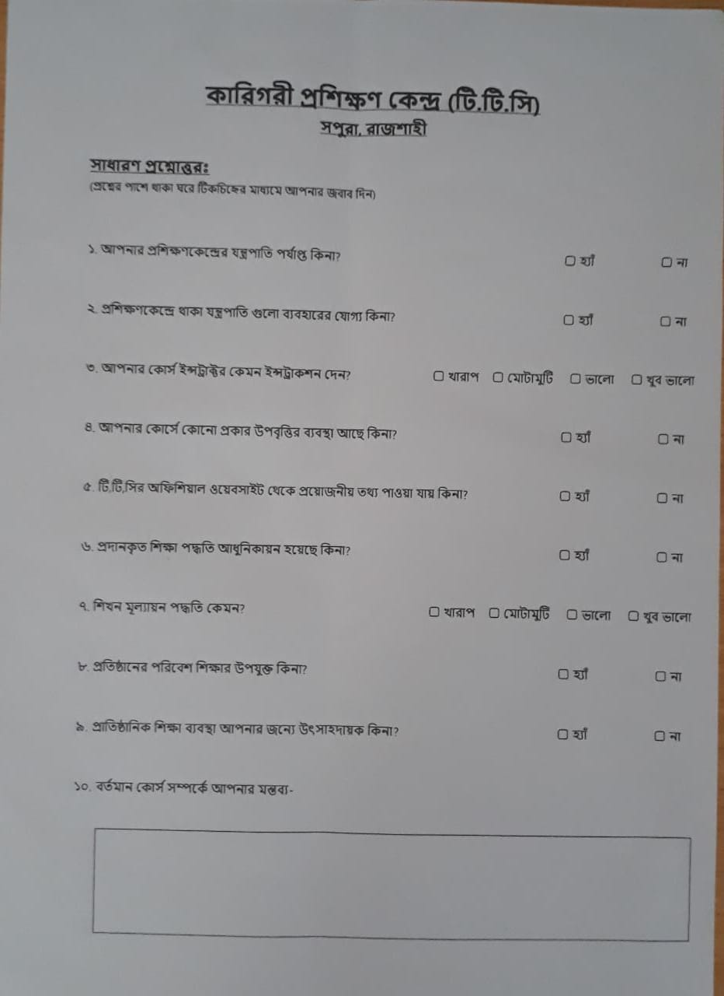

|  |  |  |
| --- | --- | --- |
| Question no | Yes | No |
| 1 | 8 | 2 |
| 2 | 6 | 4 |
| 4 | 7 | 3 |
| 5 | 9 | 1 |
| 6 | 4 | 6 |
| 8 | 9 | 1 |
| 9 | 9 | 1 |

Question no 3: Worst(5%),average(5%),good(25%),best(65%)

Question no 7:Worst(5%),average(10%),good(70%),best(15%)

Question no 10:Instructors are good enough,All the things teached practically.One of the problem is load-shedding happens sometimes.

**3.3 Overview of the candidate examination control system.** The Data flow diagram (DFD) was first developed by Larry Constantine as a way of expressing system requirements in a graphical form; this led to a modular design. A DFD, also known as a “bubble chart”, has the purpose of clarifying system requirements and identifying major transformations that will become programs in system design. So it is the starting point of the design phase that functionally decomposes the requirements specifications down to lowest level of detail. A DFD consists of a series of bubbles joined by lines. The bubble represent data transformations and the line represents data flows in the system. **The DFD of proposed exam system of technical training center,rajshahi**

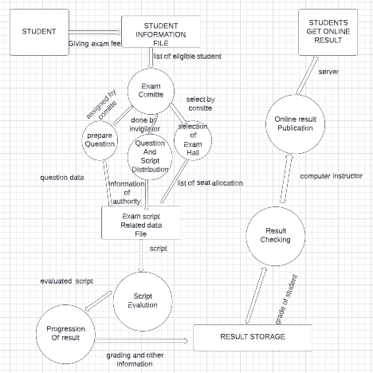

**3.3.1 A brief description of examination control system**

We have shown the examination control system of the technical training center. The process starts with the students. Students are the source of the system. They complete the registration process by giving course fee. The office send the list of eligible students to the exam committee. Exam committee stores these information in their database with care. Then the first process of examination starts through the transmission of the student data. Then this process of exam completes through three sub processes which are prepare question, question and exam script distribution and selection of exam hall. The first sub process is preparing exam question.Committee assigned respected instructor to set question. This selection process is done based upon experience and special training.Then the next sub process is question and exam script distribution. The available teacher is assigned to guard the hall and play the role of invigilator.They distribute the exam script and question on time. Finally the arranging examination process completes with the selection of exam hall . The institutions selected as exam centers selects invigilators and prepare seat plan.The documents of examination hall selection and arranging examination process are stored in data file. The next process is to evaluate the answer scripts. The theory scripts are distributed to the selected examiners. The examiners are given deadline within that deadline they have to complete their evaluation. After evaluation of the exam scripts they submit the mark sheet and the exam scripts to the head examiner and then the head examiner submit the final mark sheet to the office. The OMR sheet checking process is done by the third party organization. Board selects these third party organization. After getting the evaluated theory script marks marks the third process of creating final result starts. This process ends with storing the result and grade the result. Next process is to check the stored result. The result is stored in data file after getting the marks from the examiners . Then corresponding graded result is checked in this process that whether there is any mistake or not. Then the processed and checked result is given to computer operator who handle the website, to publish it online. Through the publication of result overall examination control process ends. Lastly the students get their result through the online server of the institution.

**3.3.2 Conclusion:** Information gathering is an art and a science. A key point of feasibility study is gathering information about the present system. That’s why to gather information we have used four tools. That means we collected the required information using four different criteria. These tools are very useful because the information can be collected by using these tools very effectively. System can be observed closely and at the same time this is an opportunity to build up an amicable relationship with the staffs of the respective organization. By gathering information using the four tools we have mentioned we came to know the actual need of the organization. It will help us in our analysis about the present system. Lastly we sketched a data flow diagram which is a graphical representation of the proposed system of technical training center.Their is not any existing exam system.Only a final exam is taken under board.Their is not any internal examination wich is not good for the students.Without the exam students can not know their lackings and will not be attentive in their study. By data flow diagram one can easily understand and can get a idea of the exam system. So there is important of information gathering to get a idea about existing system and to get a idea about the requirement of candidate system.